**Selenium Assignments**

Passing Value Without Send keys:

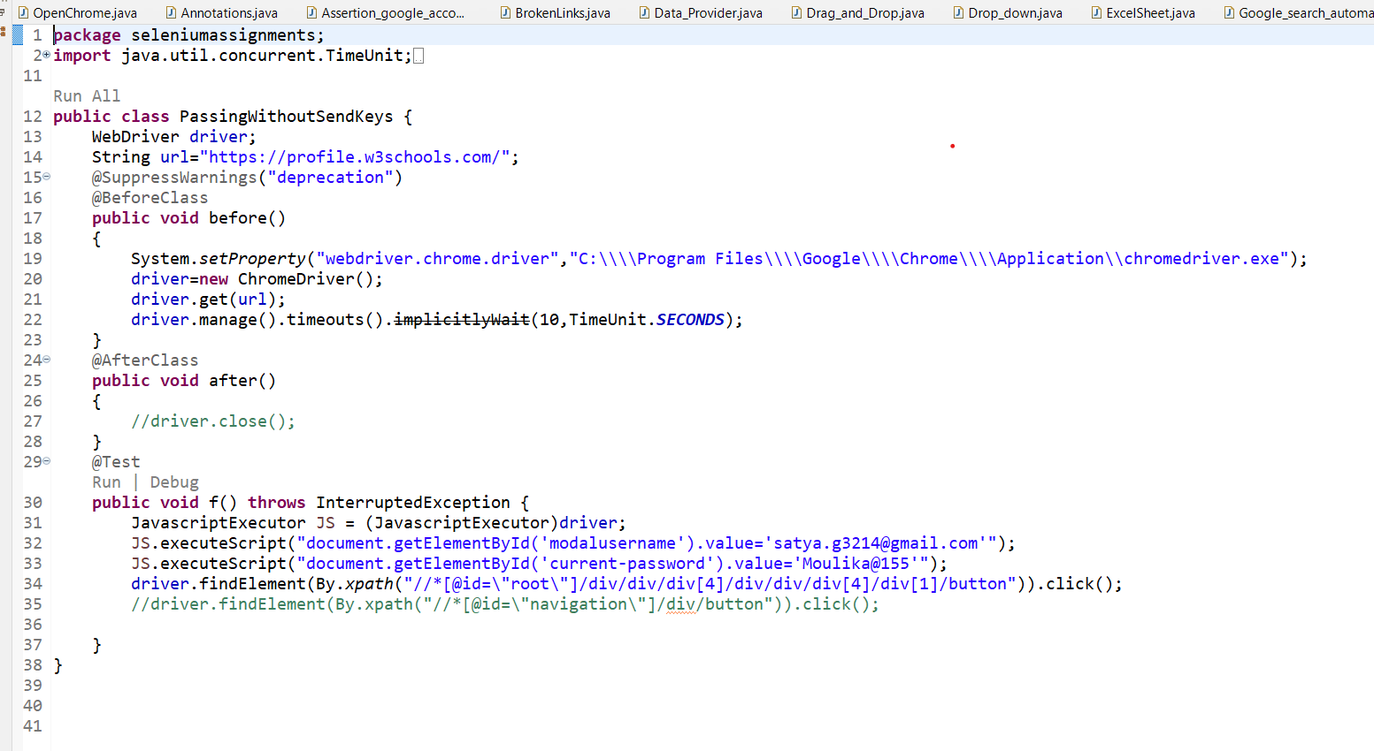

OUTPUT:

